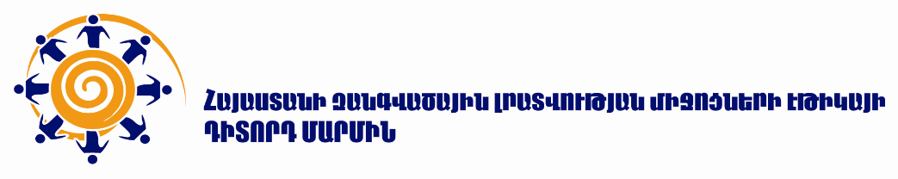
October 9, 2023

JOINT STATEMENT OF MEDIA ETHICS OBSERVATORY AND INFORMATION DISPUTES COUNCIL ON THE INADMISSIBILITY OF DISCRIMINATION AND THE SPREAD OF HATE SPEECH

On October 2, 2023, Media Ethics Observatory (MEO) and Information Disputes Council (IDC), had released a joint statement “On the inadmissibility of discrimination and the spread of hate speech.” The statement expressed deep concern that the lack of information and the internal political crisis that emerged during the days of the ethnic cleansing by the Azerbaijani regime in Artsakh (September 19 and 20, 2023) and heightened public anxiety within the country had resulted in a split among journalists, media, and social network users, aligning them with opposing political forces and putting professional principles on the back burner.

In particular, civic.am had mentioned that the young people vandalizing cars, insulting people, and intimidating drivers in Yerevan’s center “were from Karabakh.” When faced with rightful backlash on social media against the publication, the website attempted to satirize their “regret note” by stating: “Taking into account the public demand of our readers, we will no longer mention their origins when reporting on incidents involving intimidation, assaults, ordinary citizens’ property damage caused by these individuals.” This sarcastic response from the media to its audience is unacceptable. A similar “regret note” was also shared by araratnews.am.

Media Ethics Observatory and Information Disputes Council find the dissemination of texts inciting hatred and promoting discriminatory attitudes against the people of Artsakh as unacceptable. It is equally unacceptable when individuals with varying ideological and political views, including media representatives, disseminate such content about each other through media and social networks.

Looking at the issue from a legal perspective, we declare that expressions spreading intolerance, discrimination and hostility (commonly referred to as hate speech) cannot fall under the protection of free speech within the RA legislation or international law.

Unfortunately, there was an error in the text of the joint statement by MEO and IDC. The examples referenced, reportedly from 24news.am, particularly the video headlines, had mistakenly been used as a basis for the MEO and IDC statement. However, in reality these instances were as a result of users acting in bad faith, or perhaps also an intentional effort to damage the media.

In this regard, MEO and IDC published a refutation on the same day, expressing apologies to their colleagues from 24news.am.

MEO and IDC, in addition to the October 2, 2023 statement on the inadmissibility of discrimination and hate speech, highlight some content sharers acting in bad-faith. In particular, these individuals, using 24news.am videos and preserving their logo, altered the headlines of circulating videos to their advantage, spreading discriminatory and hateful content across the Internet. This manipulative “trick” contradicts quality reporting and misleads Internet users. The legal and ethical regulations protecting copyright have also been grossly violated.

MEO and IDC remind that the key in this case is not so much about being “error-free” but acknowledging mistakes promptly, rectifying them, issuing apologies, examining the circumstances of their occurrence and establishing preventive measures against their recurrence in the future, precisely as executed by MEO and IDC.

We urge journalistic and media organizations to remain vigilant against manipulative tactics, safeguarding media logos from jeopardy.

We urge the media encountering manipulative use of their logos, to not solely rely on social media posts, but to widely inform the journalistic community, release official statements and publicly appeal to law enforcement agencies.

We call to refrain from looking for political connotations in the assessments related to similar misunderstandings, which, unfortunately, was observed in specific reactions concerning our retracted statement. We reiterate that in a tense domestic political environment, it is vital to cross-verify news sources and promptly admit mistakes.

Media Ethics Observatory
Information Disputes Council

The quotations are presented in their unaltered form

